BroadLight ODS Proxy

Rodney Peng
2012/3/20

The BroadLight Open Development System(ODS) is a GPON OLT system for ONT development and testing. It has two interfaces support configuration of low level driver and OMCI functions. The driver control interface (which is called BL Shell) is exported from a telnet server listening on TCP port 20000 and the OMCI control interface (which is called BL Console) is exported from a serial console with baud rate 9600 bps.

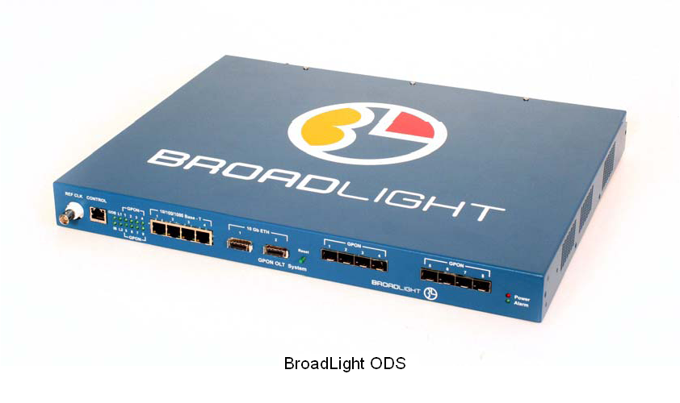
The ODS has 4 PON ports, it should allow multiple users to share the system for development and testing if each user can use different PON port(s) and ONT(s). Since there is only one interface for each driver and OMCI control, it is really inconvenient to share the control consoles between multiple users considering user needs to take time to type in command, check configuration and status, and run his own scripts.

The ODS Proxy is an application software that can let user share the control interfaces of the ODS. It serves both as a client connected to ODS control interface and as a telnet server accepts user’s telnet client session. Currently each server can support up to seven client connections.

Telnet
Telnet
COM Port
Telnet
Shell Server
Console Server
BL Shell
BL Console
User
User
ODS
ODS Proxy
Installation:

The archive contents following files:
ODS_Proxy.jar: main program file
lib/*.jar: Java libraries used by ODS_Proxy.jar
RXTX/RXTXcomm.jar: Java serial port library
RXTX/rxtxSerial.dll: Serial port library for Windows

Please install Java Runtime Environment (JRE), and copy following files from archive:
ODS_Proxy.jar and lib/*.jar go to a user-created folder
RXTX/RXTXcomm.jar goes to “lib/ext” under JRE installation folder
RXTX/rxtxSerial.dll goes to “bin” under JRE installation folder

Create a shortcut which runs command “java –jar ODS_Proxy.jar”
Execute the shortcut and the main window shows.

Once setup as the example below, you can telnet to port 1234 and 5678 on the PC physically connects to the ODS to control the ODS remotely.
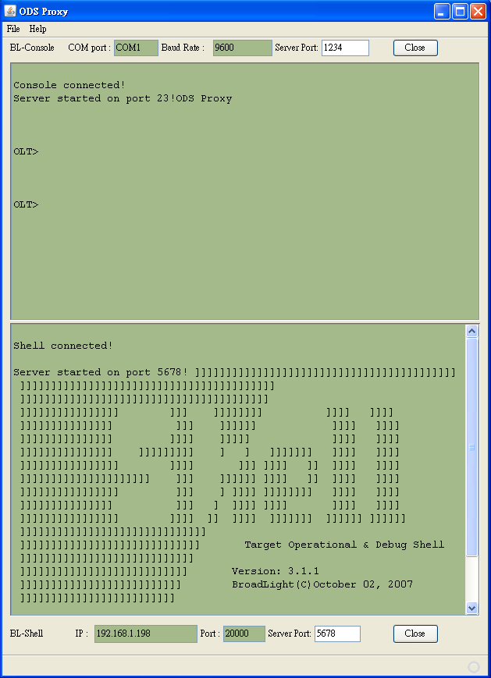

The upper panel is connected to BL Console. There are three configuration parameters:

COM port: the name of the serial port
Baud Rate: baud rate of the serial port (9600 bps for ODS)
Server Port: the TCP listening port

The lower panel is connected to BL Shell. There are three configuration parameters:

IP: IP address of the ODS (192.168.1.198 usually for ODS)
Port: TCP port of the ODS (20000 for ODS)
Server Port: the TCP listening port

Both shell and console server supports following special commands:

“***ods 0” will unlock the control interface.

“***ods 1” will lock the control interface. Only the user who first entered the command has input access to the control interface. Other users will see a message “Terminal is locked!” and the input will be ignored. During the lock-out, other users still can see the message from ODS. Without the lock command, every user’s input will be sent to the ODS and mixed together.

“***ods 2” will show connected clients. The connection marked with “(locked)” means its terminal is locked by another user (which is the one without the mark “(locked)”).

“exit” will close the telnet session. This command will not be sent to the ODS to avoid closing the BL shell accidently.

Please configure your telnet client to send both CR and LF for new line. Otherwise your terminal won’t work. For Tera Term, please make sure “CR+LF” is selected for the Transmit option as shown below:

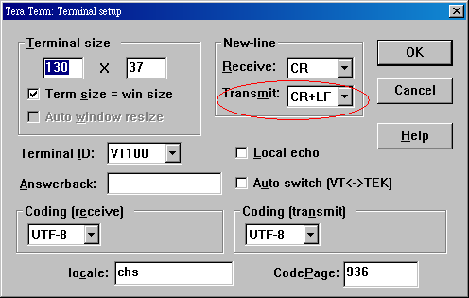

Following is a sample Tera Term script to show how to use the lock/unlock command:

;-----------------------------------------------------------------
timeout = 3

sendln ' '
sendln '***ods 1'
waitln 'OK locked'

if result = 0 goto abort

; includes your existing scripts here

pause 3
sendln '***ods 0'

goto end

:abort
messagebox 'Terminal is locked ! ' 'ODS'

:end
;-----------------------------------------------------------------

